ABSTRACT
In recent years forecasting of financial data such as interest rate, exchange rate, stock market and bankruptcy has been observed to be a potential field of research due to its importance in financial and managerial decision making. Survey of existing literature reveals that there is a need to develop efficient forecasting models involving less computational load and fast forecasting capability. The present paper aims to fulfill this objective by developing a novel ANN model involving nonlinear inputs and simple ANN structure. These are: functional link artificial neural network (FLANN) and genetic algorithm based neural networks .These have been employed to predict currency exchange rate between US$ to British Pound, Indian Rupees and Japanese Yen. The performance of the proposed models has been evaluated through simulation and has been compared with those obtained from standard LMS based forecasting model. These preliminary results suggest that genetic algorithms in conjunction with neural networks are promising methods for extracting profitable trading rules. The genetic algorithm is a search heuristic that is routinely used to generate useful solutions to optimization and search problems. It generates solutions to optimization problems using techniques inspired by natural evolution, such as inheritance, mutation, selection, and crossover. Genetic algorithms are one of the best ways to solve a problem for which little is known. They are very general algorithm and so work well in any search space. All you need to know is what you need the solution to be able to do well, and a genetic algorithm will be able to create a high quality solution. This paper proposes an improved method for stock picking using genetic algorithms based on neural networks.

INTRODUCTION
Over the last decades, there has been much research interests directed at understanding and predicting future. Among them, space to forecast price movements in stock market is a major challenge confronting investors, speculator and businesses. In their quest to forecast the markets, they assume that future occurrences are based at least in part on present and past events and data. However, financial time series are among the ‘noisiest’ and most difficult signals to forecast.
While rule-based technologies improved dramatically, many of stock market applications were less than successful. For this reason, the trend towards automatic learning systems is particularly evident in the financial services sector. Advances in chaos theory provide the theoretical justification for constructing non-linear models, which is typically the goal in machine learning. Previous studies on this issue suggest that artificial intelligence techniques such as artificial neural networks (ANN) have more frequent chances to detect nonlinear patterns in stock market. ANN, however, has a drawback that the users of the model cannot readily comprehend the final rules.
In this thesis we propose data mining approach using genetic algorithms (GAs) based neural networks to solve the knowledge acquisitions problems that are inherent in constructing and maintaining rule based applications for stock market. Genetic algorithms have been used in conjunction with neural networks in major ways. First they have been used to set the weights. This includes both supervised learning applications and reinforcement learning applications related work, a genetic algorithm has been used to set the learning rates which in turn are used by other types of learning algorithms. GA’s have also been combined with more traditional ways of gradient based search. Second, GA’s have been used to learn neural network topologies for function approximation. Third major application is the use of GA’s to select training data to interpret the output behavior of neural networks.
Financial markets data present a challenging and complex problem to understand and forecast. Forecasting is also a key element of financial and managerial decision making. The main purpose of forecasting is to reduce the risk in decision making that is important for financial organizations, firm and private investors. The common financial time series that need forecasting are stock prices, interest rates, price indices and currency exchange rates. These time series are known to be complex, difficult for econometric modeling, non-stationary, very noisy and badly fitted by linear models (Bodyanskiy & Popov,2006). The problem of economic and financial forecasting has recently drawn the attention of many researchers. During last decades several methods have been proposed that differ in goals of forecasting, nature of information used and the mathematical tool employed. The first social-economic forecasting approach is reported in (Theil, 1966) which mainly relies on expert judgments and mathematical programming. This approach estimates long term prediction and does not provide short term predictions of some specific indices in real time. Subsequently classical statistical approaches based on regression, correlation and spectral analysis have been reported (Brillinger, 1975; Hannan, 1979) for forecasting of financial and economic indices. However, their use is restricted due to certain constraints. These are strong autocorrelation within a series, stationary, linear structure and Gaussian nature of disturbance. However, in real life financial series, these conditions are not satisfied which lead to poor prediction quality. The Box–Jenkins forecasting approach (Box & Jenkins, 1970) based on auto-regression – integrated moving- average (ARIMA) models is an effective method but mainly relies on correlation analysis which associates its drawbacks. Subsequently adaptive techniques (Goodwin et al., 1981; Montgomery et al., 1990) are introduced in time series forecasting using learning models. These methods proved effective under conditions of non-stationary, less data and sudden changes etc. However these methods employ linear structure which degrades their prediction performance.

LITERATURE SURVEY
In refer. (T. Kimoto, 1990) used several learning algorithm and prediction method for the Tokyo stock exchange prices index (TOPIX) prediction system. This system used modular neural network that learned the relationships between various factors. The output of this system was the best timing for when to buy and sell stocks. They executed simulation of buy and sell stocks to evaluate the effect of system. In this study, vector curve, turnover ratio, foreign exchange rate and interest rate were used as input variables. Trading profit using this system revealed more than that of “Buy and hold strategy”.
In refer. (K.Kamijo, 1990) classified the changing pattern of TOPIX to triangle pattern by use of candlestick chart. They have learned these patterns using the recurrent neural network. The test set of triangle was accurately classified in 15 out of 16 experiments. (H.Ahmadi, 1990) tried to test the ‘Arbitrage pricing theory (APT)’ by ANN. This study used back propagation neural network with generalized delta rule to learn relationship between the return of individual stocks and market factors.
In refer. (R.R. Trippi, 1992) executed daily prediction of up and down direction of S&P 500 Index Futures using ANN. Generating a composite recommendation for the current day's position. Input variables in this study were technical variables for the two-week period to the trading day, open, high, low, close price, open price and the price fifteen minutes after the market opening of the current trading day. The output variable was long or short recommendation. They performed composite rule generation procedure to generate rules for combining outputs of networks. They reported prediction accuracy was 45.3% - 52.8%.
In refer. (L. S. Duke 1993) also executed daily prediction of German Government Bond Futures using feed-forward back propagation neural network. In this study, they used opening range (obtained from the highest and lowest bids at the open), highest, lowest price, closing price, volume of traders, open Interest, industrial production, consumer prices, current account balance, unemployment rates, short and long term interest rates, wholesale price index, M3 combined supply and benchmark bond yield of the network's predictions as compared to the actual movement was 53.94%.
In refer. (David de la Fuent, 2006) have presented a work which also attempts to optimize the timing of an automated trader. They use GA to develop trading rules for short time periods, using Technical Indexes, such as RSI, as GA’s chromosome. They proposed the use of the developed rules on stocks of Spanish company. However, the description in that work was too preliminary to allow for a comparison with our system to be made.
And also, in refer. (Cyril Schoreels, 2004) have presented a work which attempts to generate the buying and selling signals against 30 companies’ stocks in Germany (DAX30). They use combination of Technical Indexes applied to GA as well as (David de la Fuent, 2006), and then rank the stocks according with the strength of signals to restructure the portfolio. However, they don’t devise any criterion of profit cashing and loss cutting.
In the most recent times the soft computing tools based on such as multilayer artificial neural networks(ANN) (Kingdon, 1997; Refenes et al., 1995; Ziurilli, 1997), Fuzzy logic(FL) (Ju, Kim, & Shim, 1997), Genetic Algorithm(GA) (Bhattacharya & Meheta, 1998), genetic programming (GP) (Neely, 1997) and hybrid tools (Hassan, Nath, & Kirley, 2007; Kim, 2006; Versace et al., 2004) have been applied to financial forecasting. Learning algorithms such as support vector machine has been employed (Huang, Nakamori, & Wang, 2005) for forecasting stock market movement direction. The forecasting of major financial activities recently reported are: (i) interest rate forecasting (Ju et al., 1997; Oh & Han, 2000) (ii) exchange rate forecasting (Lebaron, 1991; Muller et al., 1990; Pictet et al., 1992; Tambi, 2005) (iii) stock market forecasting (Chun & Park, 2006; Hassan et al., 2007; Huang et al., 2005; Leigh, Hightower, & Modani, 2005) and (iv) bankruptcy prediction (Odomand & Sharda, 1990; Wilson & Sharda, 1994). From the study of the existing literature on financial forecasting it is observed that improved exchange rate prediction is an important area of present day research in financial market. Many latest evolutionary computation tools have been applied for this purpose. Out of these the MLANN involves more computation. Second issue is the accuracy of exchange rate prediction of existing techniques. Thus there is a need to develop simple but efficient nonlinear adaptive structure which involves less computation and better prediction capability. Keeping these in view we are motivated to develop efficient and low complexity forecasting models for exchange rate prediction.

PROPOSED MODEL
ARTIFICIAL NEURAL NETWORKS
Artificial Neural networks are mathematical entities that are modeled after existing biological neurons found in the brain. All the mathematical models are based on the basic block known as artificial neuron. A simple neuron is shown in figure 1. This is a neuron with a single R-element input vector is shown below. Here the individual element inputs
P_{1,}P_{2,}P_{3,}P_{4,……………………..}P_{R}

are multiplied by weights
W₁₁,W₁₂,W₁₃,W₁₄,……………….W_{1R}
and the weighted values are fed to the summing junction. Their sum is simply Wp, the dot product of the (single row) matrix W and the vector p.

Fig. 3. Simple neuron.

The neuron has a bias b, which is summed with the weighted inputs to form the net input n. This sum, n, is the argument of the transfer function f.
N=P₁ W_{1,1} + P₂ W_{1,2} + P₃ W_{1,3} + P₄ W_{1,4} + ……………….+ P_{R} W_{1,R}

The transfer function f can be one of the following commonly used functions in neural network literature:
Introducing vector notations, figure 1 can be rewritten in a more compact representation as seen in figure 2.
Fig. 4. Simple neuron in vector notation.

Here the input vector p is represented by the solid dark vertical bar at the left. The dimensions of p are shown below the symbol p in the figure as Rx1. (Note that we will use a capital letter, such as R in the previous sentence, when referring to the size of a vector.) Thus, p is a vector of R input elements. These inputs post multiply the single row, R column matrix W. As before, a constant 1 enters the neuron as an input and is multiplied by a scalar bias b. The net input to the transfer function f is n, the sum of the bias b and the product Wp. This sum is passed to the transfer function f to get the neuron's output a, which in this case is a scalar. Note that if we had more than one neuron, the network output would be a vector.
A one-layer network with R input elements and neurons are shown in figure 3.
Fig. 5. One-layer network.
In this network, each element of the input vector p is connected to each neuron input through the weight matrix W. The ith neuron has a summer that gathers its weighted inputs and bias to form its own scalar output n(i). The various n(i) taken together form an S-element net input vector n. Finally, the neuron layer outputs form a column vector a. We show the expression for a at the bottom of the figure.
Note that it is common for the number of inputs to a layer to be different from the number of neurons (i.e., R≠S). A layer is not constrained to have the number of its inputs equal to the number of its neurons.
You can create a single (composite) layer of neurons having different transfer functions simply by putting two of the networks shown earlier in parallel. Both networks would have the same inputs, and each network would create some of the outputs.
The input vector elements enter the network through the weight matrix W.
The S neuron R input one-layer network also can be drawn in abbreviated notation.
Fig. 6. One-layer network in vector notation.
Here p is an R length input vector, W is an SxR matrix, and a and b are S length vectors. As defined previously, the neuron layer includes the weight matrix, the multiplication operations, the bias vector b, the summer, and the transfer function boxes.

A network can have several layers. Each layer has a weight matrix W, a bias vector b, and an output vector a. To distinguish between the weight matrices, output vectors, etc., for each of these layers in our figures, we append the number of the layer as a superscript to the variable of interest. You can see the use of this layer notation in the three-layer network shown below, and in the equations at the bottom of the figure.
Fig. 7. Multi-layer network.
The network shown above has R¹ inputs, S¹ neurons in the first layer, S² neurons in the second layer, etc. It is common for different layers to have different numbers of neurons. A constant input 1 is fed to the biases for each neuron.
Note that the outputs of each intermediate layer are the inputs to the following layer. Thus layer 2 can be analyzed as a one-layer network with S¹ inputs, S² neurons, and an S²xS¹ weight matrix W². The input to layer 2 is a¹; the output is a². Now that we have identified all the vectors and matrices of layer 2, we can treat it as a single-layer network on its own. This approach can be taken with any layer of the network.
The layers of a multilayer network play different roles. A layer that produces the network output is called an output layer. All other layers are called hidden layers. The three-layer network shown earlier has one output layer (layer 3) and two hidden layers (layer 1 and layer 2). Some authors refer to the inputs as a fourth layer. We will not use that designation.
The same three-layer network discussed previously also can be drawn using our abbreviated notation.
Fig. 8. Multi-layer network in vector notation.
Multiple-layer networks are quite powerful. For instance, a network of two layers, where the first layer is sigmoid and the second layer is linear, can be trained to approximate any function (with a finite number of discontinuities) arbitrarily well. Here we assume that the output of the third layer, a³, is the network output of interest, and we have labeled this output as y. We will use this notation to specify the output of multilayer networks.
The previous networks considered are Feedforward in the sense of the flow of information through the network. There exist neural network architectures in which the flow of information can have loops. These are called Recurrent networks, i.e. Hopfield networks seen in the following figure.
Fig. 9. Recurrent neural network.

Learning and Training Neural Networks

Training of neural networks is done by devising learning rules. A learning rule is a procedure for modifying the weights and biases of a network. (This procedure may also be referred to as a training algorithm.) The learning rule is applied to train the network to perform some particular task. Learning can be categorized into:

Supervised learning: the learning rule is provided with a set of examples (the training set) of proper network behavior
where p_{q} is an input to the network, and t_{q} is the corresponding correct (target) output. As the inputs are applied to the network, the network outputs are compared to the targets. The learning rule is then used to adjust the weights and biases of the network in order to move the network outputs closer to the targets. The Perceptron learning rule falls in this supervised learning category. There is also the Supervised Hebbian learning.
Supervised learning is used in general to tackle pattern recognition, data classification, and function approximation problems.

Unsupervised learning: the weights and biases are modified in response to network inputs only. There are no target outputs available. Most of these algorithms perform clustering operations. They categorize the input patterns into a finite number of classes. This is especially useful in such applications as vector quantization. Unsupervised Hebbian learning, Competitive learning, and Associative learning are examples of this.
Reinforcement Learning: Similar to supervised learning, except that, instead of providing the correct output for each network, the algorithm is only a given a grade which indicates the performance of the network. Think of it as Reward/Penalty type of learning. Temporal difference learning, Q-learning, Value-Iteration, Policy Iterations, Adaptive Critics, are all variants of reinforcement learning methods.
Reinforcement learning is used extensively to solve problems involving optimal control, Markov Decision Problems MDP, and other dynamics programming related learning problems.
In this short document, we focus on supervised learning. In particular, we briefly mention Perception learning, Supervised Hebbian learning, LMS, and Error Back propagation. It is recommended though to learn this material from the referenced sources .
WHY NEURAL NETWORK IS BEST FOR PREDICTION??
There are several distinguished features that propound the use of neural network as a preferred tool over other traditional models of prediction [5]. Artificial neural networks are nonlinear in nature and where most of the natural real world systems are non linear in nature, artificial neural networks are preferred over the traditional linear models. This is because the linear models generally fail to understand the data pattern and analyse when the underlying system is a non linear one. However, some parametric nonlinear model such as Autoregressive Conditional Heteroskedasticity (Engle, 1982) and General Autoregressive Conditional Heteroskedasticity have been in use for stock prediction. But most of the non linear statistical techniques require that the non linear model must be specified before the estimation of the parameters is done and generally it happens that pre-specified nonlinear models may fail to observe the critical features of the complex system under study. Artificial neural networks are data driven models. The novelty of the neural network lies in their ability to discover nonlinear relationship in the input data set without a priori assumption of the knowledge of relation between the input and the output (Hagen et al., 1996) the input variables are mapped to the output variables by squashing or transforming by a special function known as activation function. They independently learn the relationship inherent in the variables from a set of labelled training example and therefore involves in modification of the network parameters. Artificial neural networks have a built in capability to adapt the network parameters to the changes in the studied system. A neural network trained to a particular input data set corresponding to a particular environment; can be easily retrained to a new environment to predict at the same level of environment. Moreover, when the system under study is non stationary and dynamic in nature, the neural network can change its network parameters (synaptic weights) in real time. So, neural network suits better than other models in predicting the stock market returns.
FUNCTIONAL LINK ARTIFICIAL NEURAL NETWORK(FLANN):
The FLANN (Pao, 1989) is a single layered neural networkwith nonlinear input and a single neuron at the output.This network is a useful substitute of multilayer artificial neural network (MLANN) (Lippman, 1987). However, it is structurally simple and involves less computations compared to those of MLANN. It is also reported that for some applications (Patra, Pal, Chatterji, & Panda, 1999) the FLANN performs better than the MLANN. Thenonlinear input is generated by functionally expanding the input vector in a nonlinear manner. Different nonlinear
expansions may be employed. These are trigonometric(sine and cosine), Chebyshev and power series. In this paper the trigonometric expansion based financial model is developed for exchange rate prediction as it offers better performance compared to when other expansions are used. The
proposed model consists of three basic processes.
2.1 THE FUNCTIONAL EXPANSION PROCESS (FE PROCESS):
In this case each input element is nonlinearly expanded to create more number of inputs. The functional expansion used should be nonlinear in nature and should involve simple computations. The number of elements after expansion becomes more than the original input points. The main objective of introducing nonlinearity to the input elements is to reduce the number of layers and thus the computational load.

2.2 THE ESTIMATION PROCESS:
It involves (i) computing the output of the adaptive model in response to nonlinear input elements (ii) generating an error signal by comparing the estimated financial output of the model with the corresponding desired or target exchange rate.
2.3. ADAPTIVE PROCESS:
It involves adaptive adjustment of connecting weights of the model using a novel weight update learning rule. The combination of these three processes together constitutes the proposed financial model as shown in Fig. 1. The detailed structure of the generalized model is depicted in
Fig. 2. In designing the adaptive forecasting model it is assumed that adequate past financial data is readily available for every day or first day of every month depending upon the requirement. From these data relevant features corresponding to each day (or month) are extracted and tabulated. Let the set of input features pertaining to a given day or month is called input pattern vector. For a particular financial forecasting case let P represents the number of input patterns out of which let N number of patterns are used for training and L patterns are used for testing the
represent the elements of a weight vector b W ðnÞ. These values computed using the FLANN
algorithm represents estimate of weight vector whose expected value may come close to the Wiener solution, W 0 (Widrow & Stearns, 2002). During training process, each expanded input pattern XðnÞ is applied to the model sequentially and the desired financial value is supplied at
the output. Given the input, the model produces an output ^dðnÞwhich acts as an estimate of the desired value. The output of the linear part of the model is computed as
where ^wbðnÞ represents the weighted bias input (may be positive or negative). This output is then passed through a nonlinear function (a sigmoid function) to produce the estimated output.

The error signal eðnÞ is the difference between the desired response and the model output and is given by:
The error eðnÞ and the input vector XðnÞ are employed to the weight update algorithm to compute the correction weight vector D^wðnÞ. Let the reflected error is given by
where f 0fyðnÞg represents the derivative of the activation function given in (4). Then the correction weight vector is given by
In the same way the change in bias weight can be obtained and is given by D^wbðnÞ ¼ gdðnÞ. A new known feature pattern is applied at the input and its corresponding D^w is computed as
using (1) through (7). The learning coefficient,g controls the convergence rate and lies between 0 and 1(Widrow & Stearns, 2002). This procedure is repeated until all the test patterns are applied. Application of all the N patterns constitutes one experiment and at the end of each experiment N sets of D^wðnÞ are obtained. Then the average change of weight of the ith weight in the ith experiment is computed.The weights of the FLANN model is then updated according to the relation
For the ith iteration it is given as:

GENETIC ALGORITHM:
Application of GA in the context of data mining is generally for the task of hypothesis testing and refinement, where the user poses some hypothesis and the system first evaluate the hypothesis and seek to refine it. Hypothesis refinement, where the user poses some hypothesis and the system first evaluates the hypothesis and then seeks to refine it. Hypothesis refinement is achieved by “seeding” the system with the hypothesis and then allowing some or all parts of it to vary. One can use a variety of evaluation functions to determine the fitness of a candidate refinement. The important aspect of the GA application is the encoding of the hypothesis and evaluation function for fitness. Another way to use data mining is to design a hybrid techniques by blending one of the know techniques with GA (Arun K. Punjari, 2001).
GA is search algorithm based on the mechanics of natural selection and genetics and they combine survival of the fittest among string structures to form a search algorithm (L. Davis, 1991). GA is particularly suitable for multi-parameter optimization problems with an objective function subject to numerous hard and soft constraints. The main idea of GA is to start with a population of solutions to a problem, and attempt to produce new generations of solutions which are better than the previous ones. GA operates through a simple cycle consisting of the following four stages: initialization, selection, crossover, and mutation. Figure 1 shows the basic steps of proposed genetic algorithms model.
In the initialization stage, a population of genetic structures (called chromosomes) that are randomly distributed in the solution space is selected as the starting point of the search. These chromosomes can be encoded using a variety of schemes including binary strings, real numbers or rules. After the initialization stage, each chromosome is evaluated using a user-defined fitness function. The goal of the fitness function is to numerically encode the performance of the chromosome. For real- world applications of optimization methods such as GA, the choice of the fitness function is the most critical step.
Fig.1.Basic steps of proposed model.
The mating convention for reproduction is such that only the high scoring members will preserve and propagate their worthy characteristics from generations to generation and thereby help in continuing the search for an optimal solution. The chromosomes with high performance may be chosen for replication several times whereas poor-performing structures may not be chosen at all. Such a selective process causes the best-performing chromosomes in the population to occupy an increasingly larger proportion of the population over time.
Crossover causes to form a new offspring between two randomly selected ‘good parents'. Crossover operates by swapping corresponding segments of a string representation of the parents and extends the search for new solution in far-reaching direction. The crossover occurs only with some probability (the crossover rate). There are many different types of crossover that can be performed: the one-point, the two-point, and the uniform type.
Mutation is a GA mechanism where we randomly choose a member of the population and change one randomly chosen bit in its bit string representation. Although the reproduction and crossover produce many new strings, they do not introduce any new information into the population at the bit level. If the mutant member is feasible, it replaces the member which was mutated in the population. The presence of mutation ensures that the probability of reaching any point in the search space is never zero.
GA’s search the solution space of a function through the use of a simulated evolution, i.e. , the survival of the fittest strategy. In general, the fittest individuals of any population tend to reproduce and survive to the next generation, thus improving successive generations. However, inferior individuals can, by chance, survive and also reproduce. Genetic algorithms have been shown to solve linear and non-linear problems by exploring all regions of the state space and exponentially exploiting promising areas through mutation, crossover, and selection operations applied to individuals in the population.

Outline of the Basic Genetic Algorithm
1. [Start] Generate random population of n chromosomes (suitable solutions for the problem).
2. [Fitness] Evaluate the fitness f(x) of each chromosome x in the population.
3. [New population] Create a new population by repeating following steps until the new population is complete.
4. [Selection] Select two parent chromosomes from a population according to their fitness (the better fitness, the bigger chance to be selected)
5. [Crossover] with a crossover probability cross over the parents to form a new offspring
(Children). If no crossover was performed, offspring is an exact copy of parents.
6. [Mutation] with a mutation probability mutate new offspring at each locus (position in chromosome).
7. [Accepting] Place new offspring in a new population
8. [Replace] Use new generated population for a further run of algorithm
9. [Test] If the end condition (for example number of populations or improvement of the
best solution) is satisfied, stop, and return the best solution in current population
10. [Loop] Go to step 2
Step1: Supply a population P₀ of individuals and respective function values.
Step2: i1.
Step3: P_{i}’ Selection-function (P_{i} ⁻1).
Step4: P_{i} Reproduction-function (P_{i}’).
Step5: evaluate (P_{i}).
Step6: ii+1.
Step7: Repeat step 3 until termination.
Step8: Print out best solution found.
Fig:2. A genetic algorithm cycle
The assessment of the prediction performance and accuracy of reducing this fitness function as much as possible is done in terms of the maximum absolute difference (MAX), the Mean Absolute Percentage Error (MAPE) and the Root Mean Square Error (RMSE) [2, 16-17] and they are defined as follows:
Where N is the size of the training data set, and n= 1,2, … , N and Y_{actual} is the actual stock
market closing price and Y_{predict} is the predictor output at the n^{th} sample.
What makes GA a Good Global Optimization Tool?
• The first and most important point is that genetic algorithms are intrinsically parallel. Most other algorithms are serial and can only explore the solution space to a problem in one direction at a time, and if the solution they discover turns out to be suboptimal, there is nothing to do but abandon all work previously completed and start over. However, since GA has multiple offspring, they can explore the solution space in multiple directions at once. If one path turns out to be a dead end, they can easily eliminate it and continue work on more promising avenues, giving them a greater chance each run of finding the optimal solution.
• Due to the parallelism that allows them to implicitly evaluate many schemas at once, genetic algorithms are particularly well-suited to solving problems where the space of all potential solutions is truly huge – too vast to search exhaustively in any reasonable amount of time. It directly samples only small regions of the vast fitness landscape and successfully finds optimal or very good results in a short period of time after directly.
• Another notable strength of genetic algorithms is that they perform well in problems for which the fitness landscape is complex - ones where the fitness function is discontinuous, noisy, changes over time, or has many local optima. GA has proven to be effective at escaping local optima and discovering the global optimum in even a very rugged and complex fitness landscape. However, even if a GA does not always deliver a provably perfect solution to a problem, it can almost always deliver at least a very good solution.
• Another area in which genetic algorithms excel is their ability to manipulate many parameters simultaneously. GAs are very good at solving such problems, in particular, their use of parallelism enables them to produce multiple equally good solutions to the same problem, possibly with one candidate solution optimizing one parameter and another candidate optimizing a different one and a human overseer can then select one of these candidates to use.
• Finally, one of the qualities of genetic algorithms which might at first appear to be a liability turns out to be one of their strengths, namely, GAs know nothing about the problems they are deployed to solve. Instead of using previously known domain-specific information to guide each step, they make random changes to their candidate solutions and then use the fitness function to determine whether those changes produce an improvement.

EXPERIMENTAL RESULTS
DATA SET USED : APPLE INC(1984-2013)
1 DAY AHEAD PREDICTION
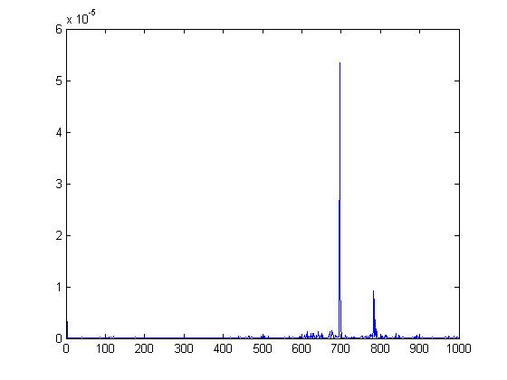
(Error during testing phase)
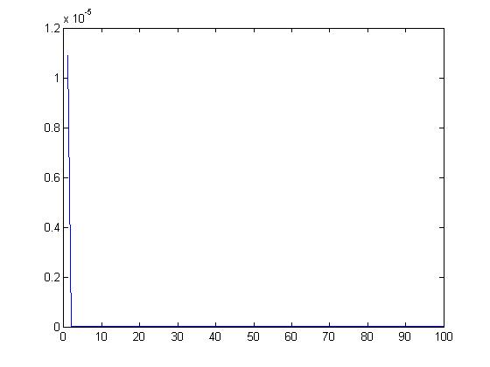
(MSE plot during testing phase)
RMSE |  | MAPE
Testing | Training | Testing | Training
4.3587e-007 | 2.6824e-005 | 10.6208 | 9.7597

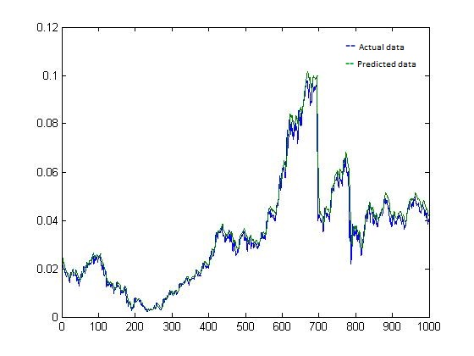
(Comparison of actual and calculated data during testing phase)
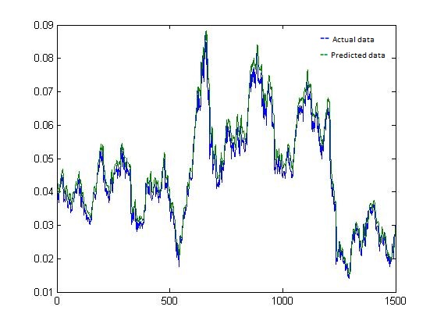
(Comparison of actual and calculated data during training phase)
5 DAY AHEAD PREDICTION
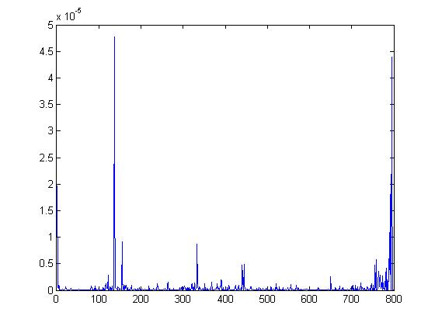
(Error during testing phase)

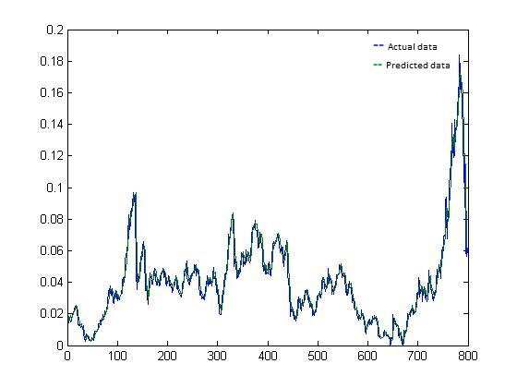
(Comparison of actual and calculated data during testing phase)

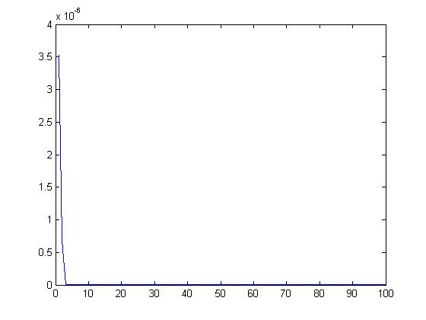
RMSE |  | MAPE
Testing | Training | Testing | Training
2.7120e-006 | 5.6344e-005 | 15.6544 | 13.743
(MSE curve in testing phase)
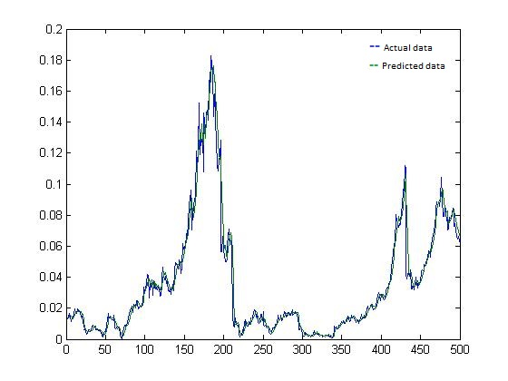
(Comparison of actual and calculated data during training phase)

10 DAY AHEAD PREDICTION
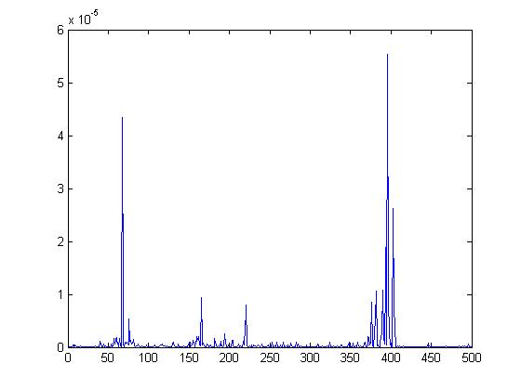
(Error in testing phase)
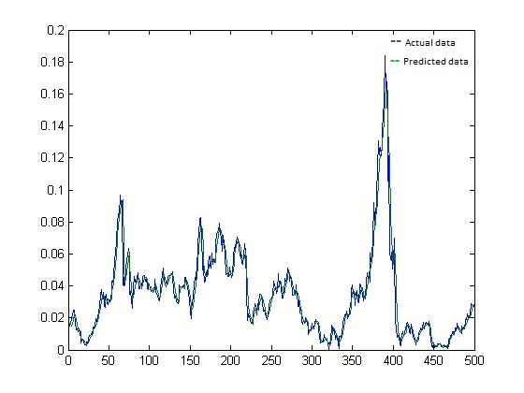
(Comparison of actual and calculated data during testing phase)

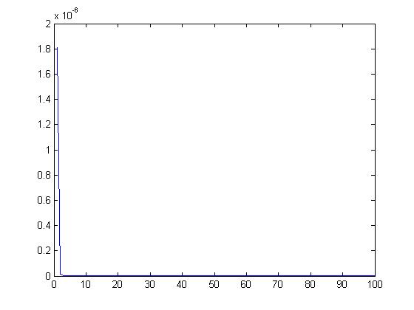
RMSE |  | MAPE
Testing | Training | Testing | Training
7.3455e-004 | 4.6675e-005 | 20.2343 | 16.344
(MSE curve in testing phase)
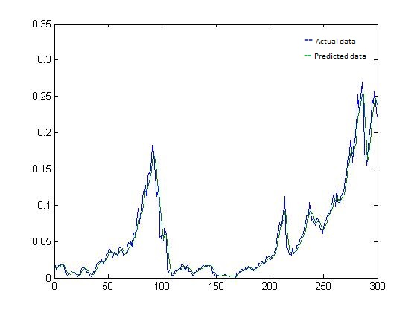
(Comparison of actual and calculated data during training phase)
15 DAY AHEAD PREDICTION
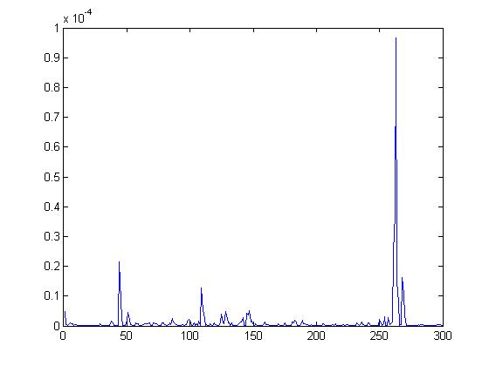
(Error during testing phase)
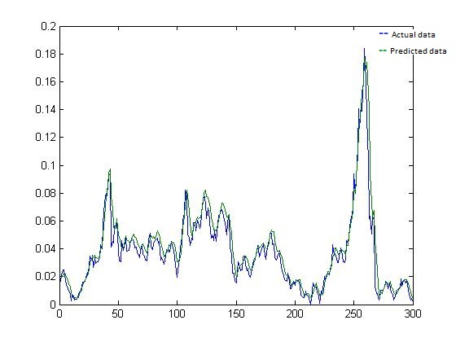
(Comparison of actual and calculated data during testing phase)

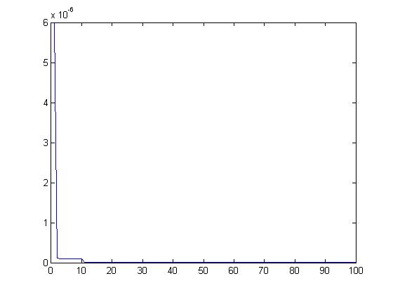 (MSE curve during testing phase)
RMSE |  | MAPE
Testing | Training | Testing | Training
9.6577e-004 | 6.3423e-005 | 14.3424 | 14.3432
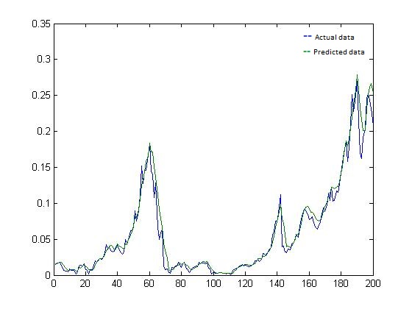 (Comparison of actual and calculated data during training phase)

DATA SET USED : GOOGLE INC (1984-2013)
1 DAY AHEAD PREDICTION
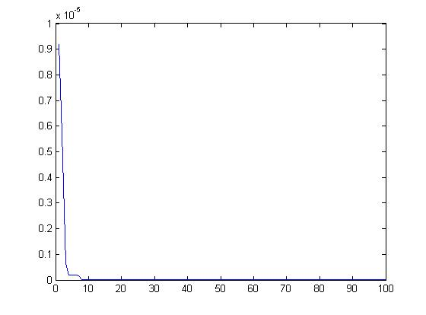
(MSE plot during testing phase)

RMSE |  | MAPE
Testing | Training | Testing | Training
5.546e-007 | 3.767e-005 | 9.5456 | 7.6786

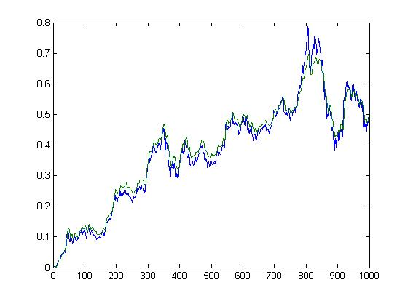
- - Actual data
- - Predicted data
(Comparison of actual and calculated data during testing phase)
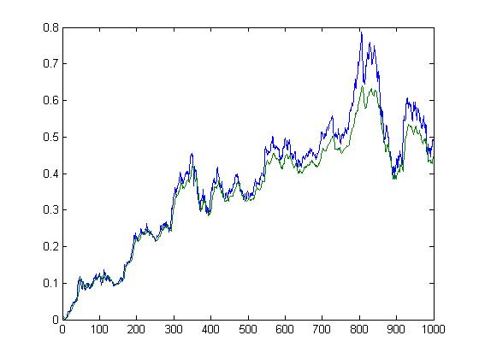
- - Actual data
- - Predicted data
(Comparison of actual and calculated data during training phase)

5 DAY AHEAD PREDICTION
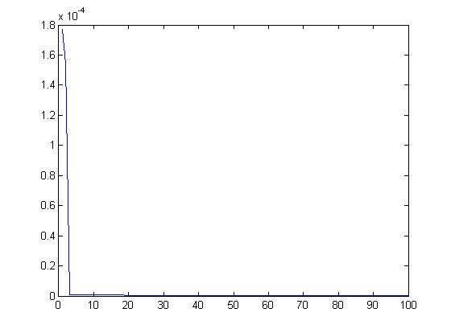
(MSE plot during testing phase)

RMSE |  | MAPE
Testing | Training | Testing | Training
1.4535e-007 | 1.2321e-005 | 5.2328 | 6.3347

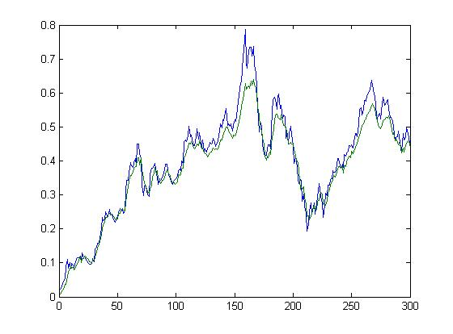
- - Actual data
- - Predicted data
(Comparison of actual and calculated data during testing phase)

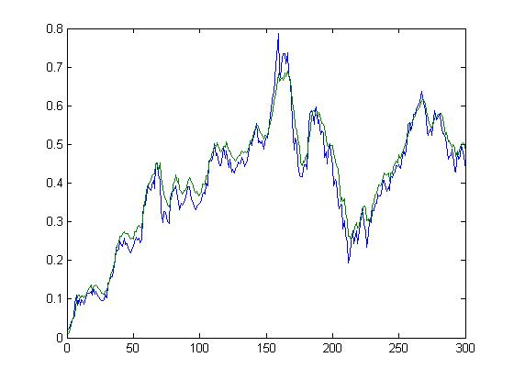
- - Actual data
- - Predicted data
(Comparison of actual and calculated data during training phase)
10 DAY AHEAD PREDICTION
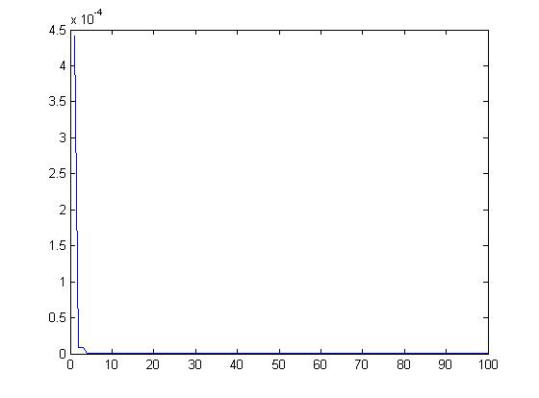
(MSE plot during testing phase)

RMSE |  | MAPE
Testing | Training | Testing | Training
6.3423e-007 | 9.2321e-005 | 18.3423 | 16.2324

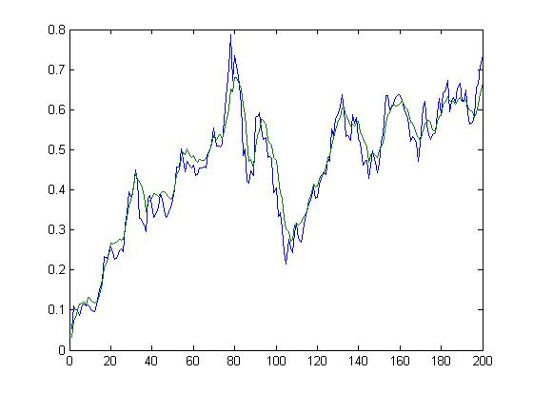
- - Actual data
- - Predicted data
(Comparison of actual and calculated data during testing phase)
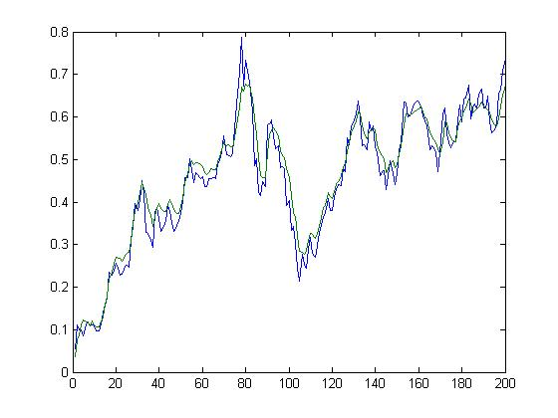
- - Actual data
- - Predicted data
(Comparison of actual and calculated data during training phase)

DATA SET USED : RELIANCE INDUSTRIES LTD (1984-2013)
1 DAY AHEAD PREDICTION

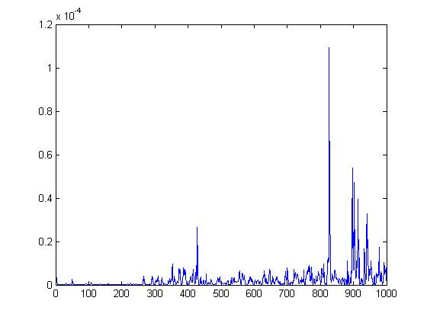
(Error during testing phase)

RMSE |  | MAPE
Testing | Training | Testing | Training
4.24234e-003 | 4.6576e-006 | 12.879 | 13.87

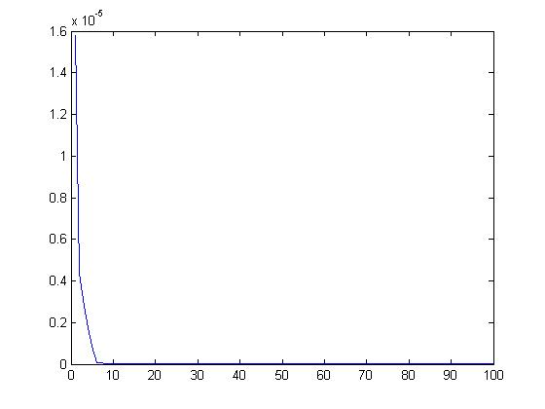
(MSE plot during testing phase)
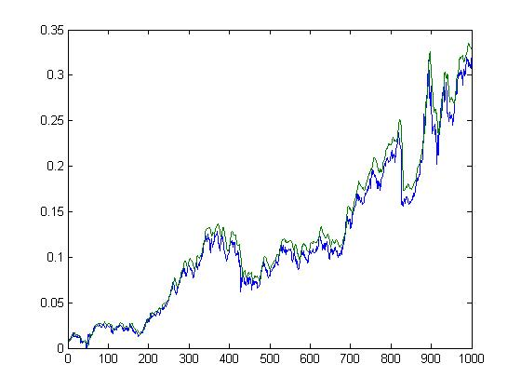
- - Actual data
- - Predicted data
(Comparison of actual and calculated data during testing phase)
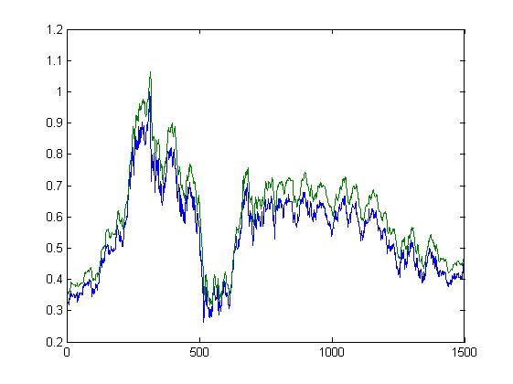
- - Actual data
- - Predicted data
(Comparison of actual and calculated data during training phase)

5 DAY AHEAD PREDICTION

RMSE |  | MAPE
Testing | Training | Testing | Training
5.435e-007 | 6.324e-005 | 8.6234 | 7.3423

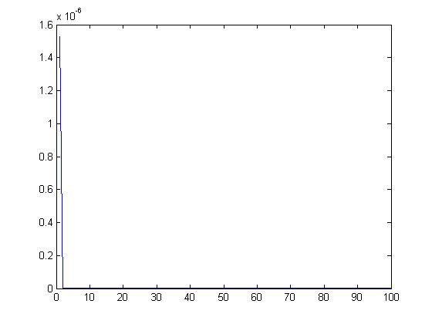
(MSE plot during testing phase)
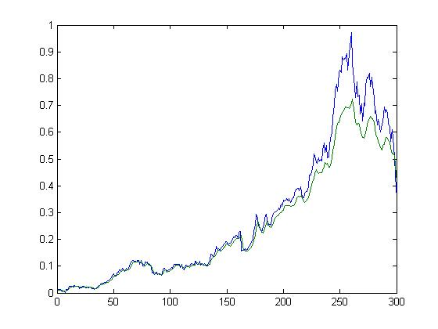
- - Actual data
- - Predicted data
(Comparison of actual and calculated data during testing phase)
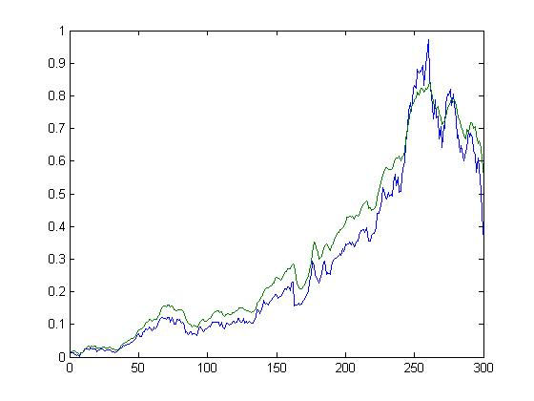
- - Actual data
- - Predicted data
(Comparison of actual and calculated data during training phase)

RMSE |  | MAPE
Testing | Training | Testing | Training
6.3587e-007 | 5.6824e-005 | 15.6248 | 21.342
10 DAY AHEAD PREDICTION
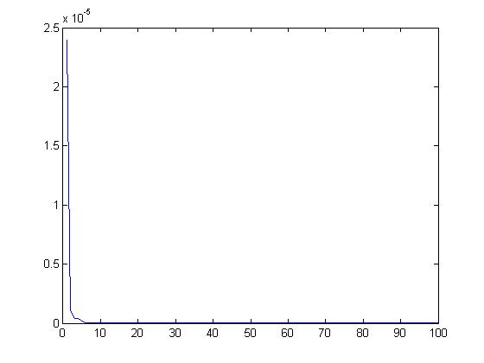
(MSE plot during testing phase)
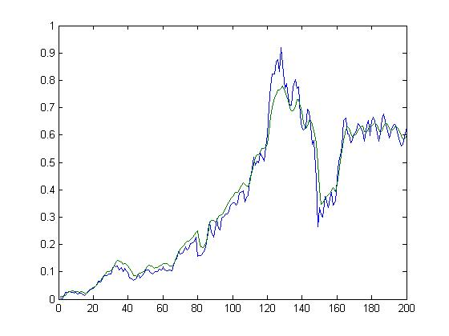
- - Actual data
- - Predicted data
(Comparison of actual and calculated data during testing phase)

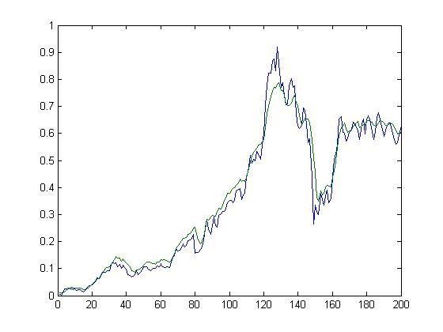
- - Actual data
- - Predicted data
(Comparison of actual and calculated data during training phase)

CONCLUSION AND FUTURE ENHANCEMENTS

To make the Genetic Algorithm applicable for generating rules for large data sets it should be
made scalable and for this purpose an incremental Genetic Algorithm is discussed in this paper which builds the model in a fine granular way. It considers each rule set for a class as a tiny component. It mines and adds rules independently to these components whenever the data distribution changes. This avoids unnecessary mining activity there by reducing learning cost and this makes the algorithm scalable with respect to size. The efficiency of the algorithm is proved by using standard data sets. In the future work attempt will be made to reduce learning time further so that GA and NN can be made suitable for fast data streams. In this paper we mine reasonable trading rules using GA and NN for India Cements Stock Price Index (ICSPI). We have found six alternative good rules which would have yielded the high return over a certain time period. Simulated results of buying and selling of trading rules were outstanding. These preliminary results suggest that GA and NN are promising methods for extracting profitable trading rules. Although the trading systems that have worked well in the past seem to have a reasonable chance of doing well in the future, we need a more extensive validation process. We need a more extensive validation process because the future is never exactly as the past. We are working towards verifying and enhancing the trading rules using current data. The challenge facing researchers interested in combinations of GA and NN want to show how GA works positively in NN arena. The application of GA in NN for reinforcement learning can also prove to be a worth-while area for future work. Combination of GA and NN are likely to also continue to impact the field of artificial life. Some limitations of GAs are that in certain situations, they are overskill compared to more straightforward optimization methods such as hill-climbing, feed forward artificial neural networks using back-propagation, and even simulated annealing and deterministic global search. To make genetic algorithm more effective and efficient it can be incorporated with other techniques within its framework to produce a hybrid genetic algorithm that can reap best from its combination. Hybrid genetic algorithms have received significant interest in recent years and are being increasingly used to solve real-world problems quickly, reliably and accurately without the need for any forms of human intervention. More research needs to be concentrated on the development of hybrid design alternatives for its efficiency enhancement.
Genetic algorithms can be applied to a wide range of problems which are NP (Non-deterministically Polynomial) complete. This means that if an enumerative search were to be carried out, it would take an exponential amount of time [4]. One of the more well researched examples is the travelling salesperson problem, where a salesperson must find the shortest route through a number of cities starting and ending at a base city. However more practical applications include strategy planning, scheduling / time tabling and machine learning [7]. To date, the approach to the use of genetic algorithms has been to develop specific programs which encode both:
- the problem information
- a genetic algorithm engine (usually incorporating characteristics inherent in the particular problem)
As a result of this, finding solutions to optimization problems can involve very intensive and costly development. Increasingly however, software is being written which separates out these two characteristics so that the problem information is input by the user rather than being hard coded. In order for there to be a wider acceptance of genetic algorithms for industrial use, the existing generic genetic algorithm engines need to be able to deal with a range of different business and scientific problems. Awareness of the power of genetic algorithms also needs to be promoted. Some examples of these products include Genesis and Genitor. To date however, these have been mainly of academic interest. In order to allow more commercial accessibility, these programs would need to be easier to operate (running under a GUI interface such as MS Windows) and allow a wide variety of problems to be solved.

REFERENCES
1. Arun K Punjari, “Data mining techniques” universities press (India) Pvt. Ltd. 2001
2. L. Davis, Handbook of genetic algorithms, Van Nostrand Reinhold, NY, 1991.
3. Y. Hiemstra, “Modeling structured nonlinear knowledge to predict stock market returns”, In Trippi, R. R. (Eds.), Chaos & Nonlinear Dynamics in the financial Markets: Theory, Evidence and Applications, Irwin, 1995, pp. 163-175.
4. K. Kohara, Ishikawa T., Fukuhara Y. and Nakamura Y., “Stock price prediction using prior knowledge and neural networks”, International Journal of Intelligent Systems in Accounting, Finance and Management, vol. 6, 1997, pp. 11-22.
5. K. Kamijo and Tanigawa T., “Stock price pattern recognition: A recurrent neural network approach’” Proceedings of the IEEE International Joint Conference on Neural Networks, 1990, pp. 1215-1221.
6. T. Kimoto, Asakawa K., Yoda M. and Takeoka M., “Stock market prediction system with modular neural networks,” Proceedings of the IEEE International Joint Conference on Neural Networks, 1990, pp. 11-16.
7. R. Tsaih, Hsu, Y. and Lai C. C., “ Forecasting S&P 500 Stock index futures with a hybrid AI system”, Decision support Systems, 1998, pp. 161-174.
8.T. Weise, “Global Optimization Algorithms - Theory and Application”. Available online at www.itweise.de/projects/book.pdf
9.Törn and A. Zilinskas, Global optimization, in Lecture Notes in Computer Science, vol. 350: Springer-Verlag, 1989

10. J. Burke, Connections, Little, Brown and Co., Boston, 1995.

11. M. Majumder and A. Hussian, MD, “Forcasting of Indian Stock Market Index Using Artificial Neural Network,” nseindia.com, pp. 1-21, 2010.

12. D. V. Setty, T. M. Rangaswamy, and K. N. Subramanya, “A review on Data Mining Applications to the Performance of Stock Marketing,” International Journal of Computer Applications, vol. 1, no. 3, pp. 33-43, Feb. 2010.

13. P. Falinouss, “Stock trend prediction using news articles,” Master’s thesis, Lulea University of Technology, pp. 1653–0187, 2007.
14. D. Zhang and L. Zhou, “Discovering golden nuggets: data mining in financial application,” Systems, Man, and Cybernetics, Part C: Applications and Reviews, IEEE Transactions on, vol. 34, no. 4, pp. 513–522, 2004.

15. J. Kutsurelis, “Forecasting financial markets using neural networks: An analysis of methods and accuracy,” 1998.

16. R. Dase and D. Pawar, “Application of Artificial Neural Network for stock market predictions: A review of literature,” International Journal of Machine Intelligence, ISSN, vol. 2, no. 2, pp. 0975– 2927, 2010.

17. E. W. Saad, D. V. Prokhorov, and D. C. Wunsch, “Comparative study of stock trend prediction using time delay, recurrent and probabilistic neural networks,” Neural Networks, IEEE Transactions on,vol. 9, no. 6, pp. 1456–1470, 1998.

18. T. Quah, “DJIA stock selection assisted by neural network,” Expert Systems with Applications, vol. 35, no. 1-2, pp. 50-58, Jul. 2008.

19. P. R. Charkha, “Stock Price Prediction and Trend Prediction Using Neural Networks,” 2008 First International Conference on Emerging Trends in Engineering and Technology, pp. 592-594, 2008.

20. M. Naeini, H. Taremian, and H. Hashemi, “Stock market value prediction using neural networks,” 2010 International Conference on Computer Information Systems and Industrial Management Applications (CISIM), pp. 132-136, Oct. 2010.

21. J. H. Wang and J. Y. Leu, “Stock market trend prediction using ARIMA-based neural networks,” in Neural Networks, 1996., IEEE International Conference on, 1996, vol. 4, pp. 2160–2165.

22. M. Thenmozhi, “Forcasting Stock Index Returns Using Neural Networks,” dbr.shtr.org, vol. 7, no. 2, pp. 59-69, 2006.

23. A. Al-Luhaib, K. Al-Ghoneim, and Y. Al-Ohali, “Dynamic Targets for Stock Market Prediction,” in Signal Processing and Communications, 2007. ICSPC 2007. IEEE International Conference on, 2007, no. November, pp. 1019–1022.

24. Q. Zhao, X. Zhao, and F. Duan, “Prediction Model of Stock Prices Based on Correlative Analysis and Neural Networks,” 2009 Second International Conference on Information and Computing Science,pp. 189-192, 2009.

